ICOM 4015

Antonio A. Tapia Maldonado

30/01/2014

# Why are we using eclipse?

Icom 4015ers by now you’ve noticed our emphasis on the use of the Eclipse IDE and if you’ve not done so you probably should start studying. Eclipse is an open source Integrated Development Environment, this means to developers (you) that Eclipse will be a collection of tools that will make their lives easier. Think that Eclipse does to programming what Microsoft Word™ does to word processing. Below are a series of steps that walk you through the alternatives to Eclipse:

## What are the alternative that we know?

### Command Line Interpreters or Shells and Text Editors

To compile and run your java application of eclipse using the command line you would have to follow through on the following steps:

1. Open your favourite Command Line Interpreter, Prompt ,Prompt Emulator or Shell Window. I’m a PC so I use CMD.

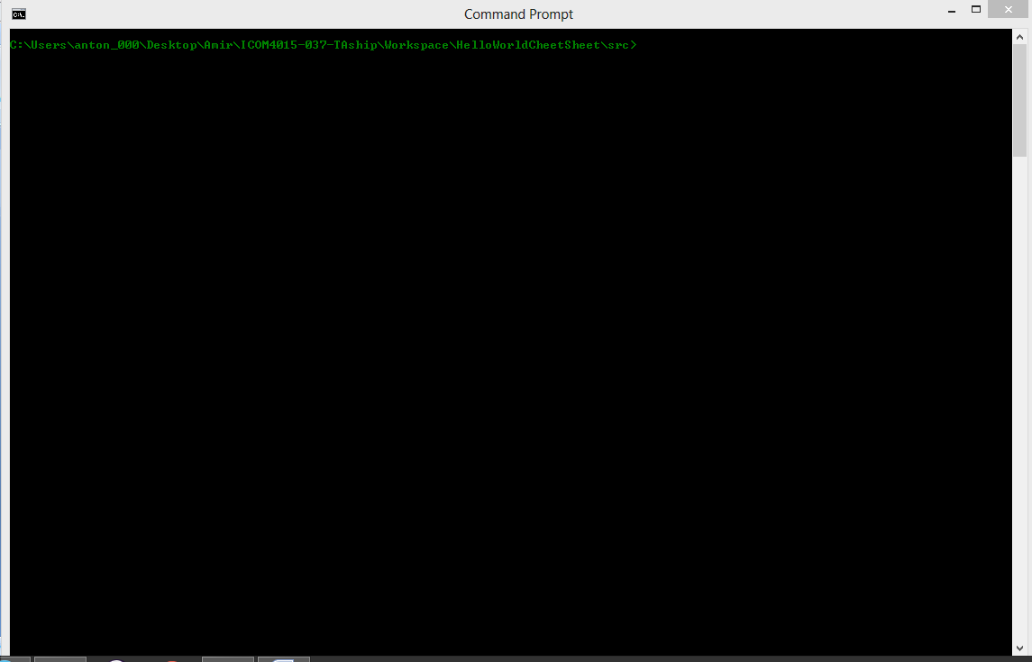

1. Write you Java on your favourite text editor(Notepad++, VIM, Notepad, Sublime, ...). For this example I will use notepad.

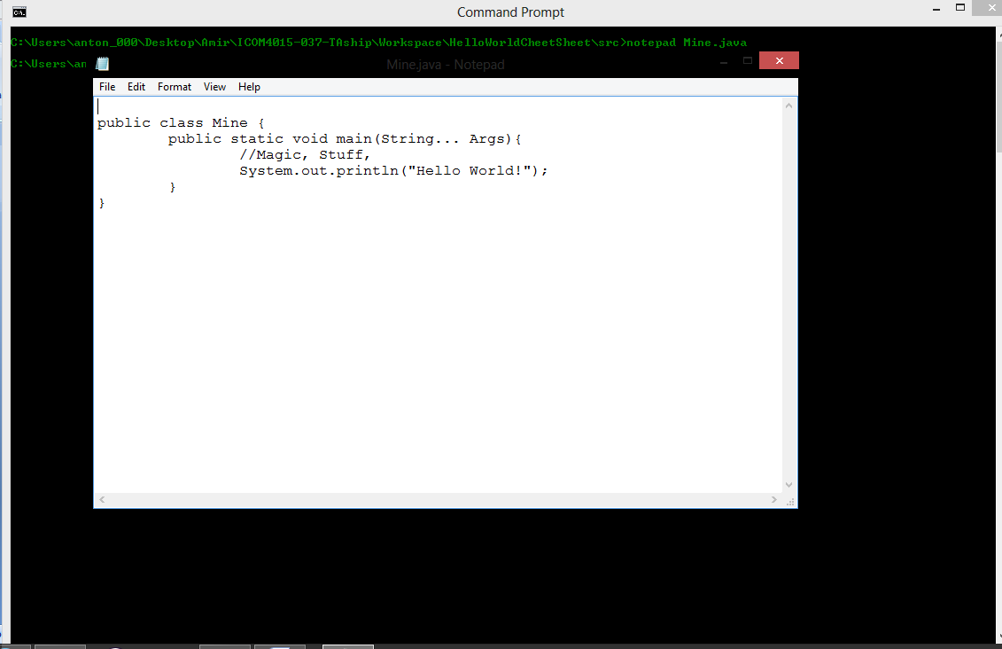

1. Utilize the “Javac” (java compiler command) Command to compile your code. Please do note that you a JDK for this.

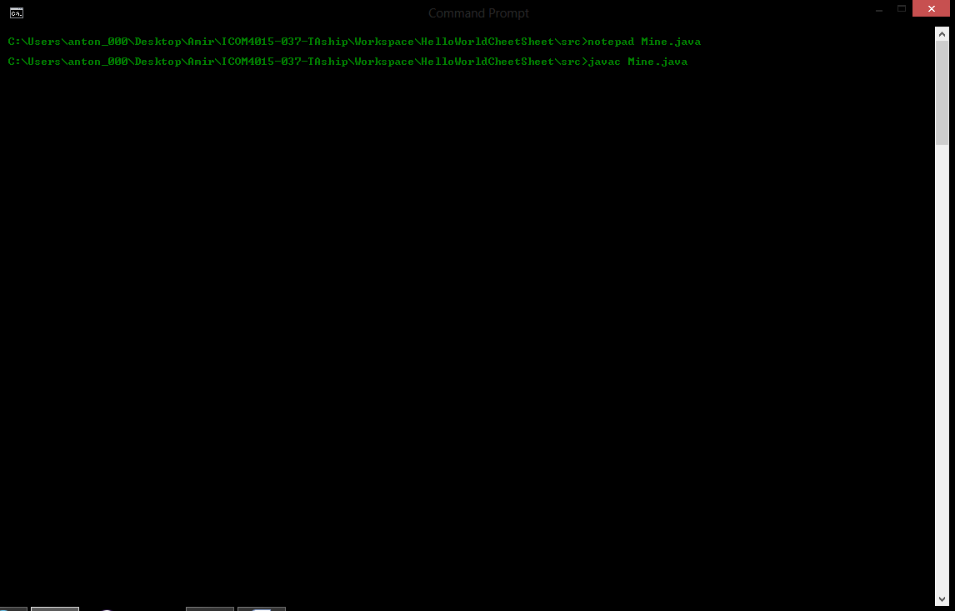

1. (Optional) Now to show that the file was successfully compile you can execute the “dir” (directory Command) command ,”ls”(list command) if you’re a ‘nix guy/gal, to verify that a *.class file was created.

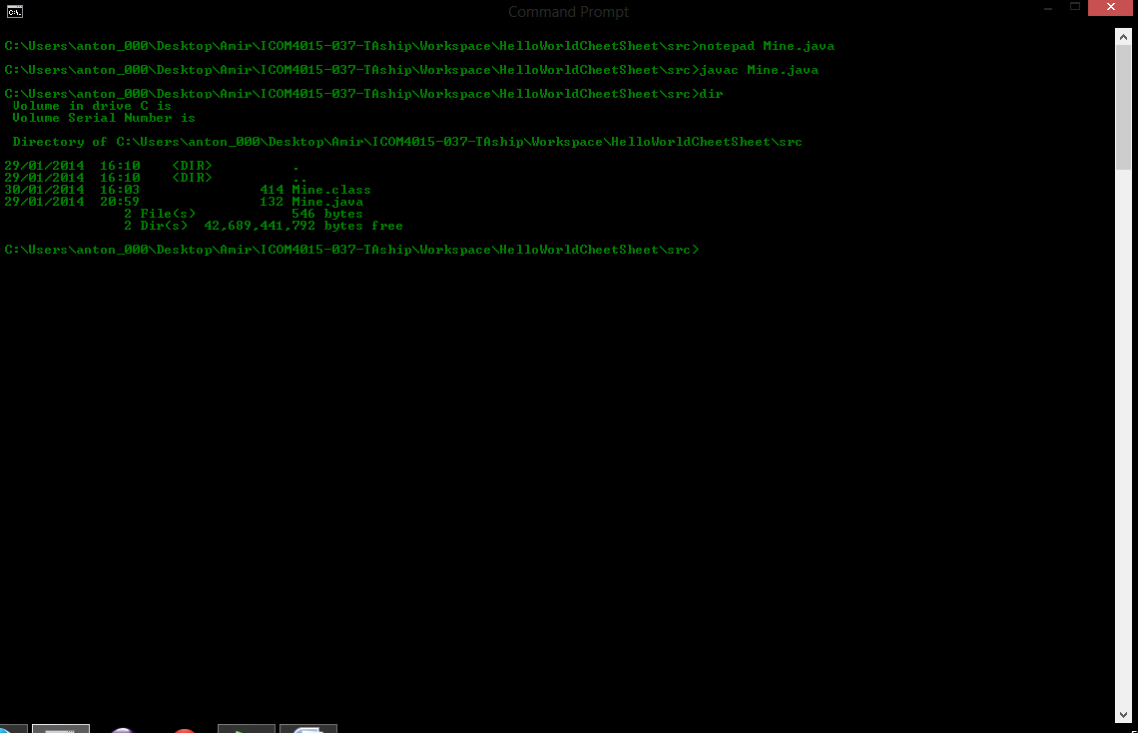

1. Now we are ready to execute the resulted *.class.

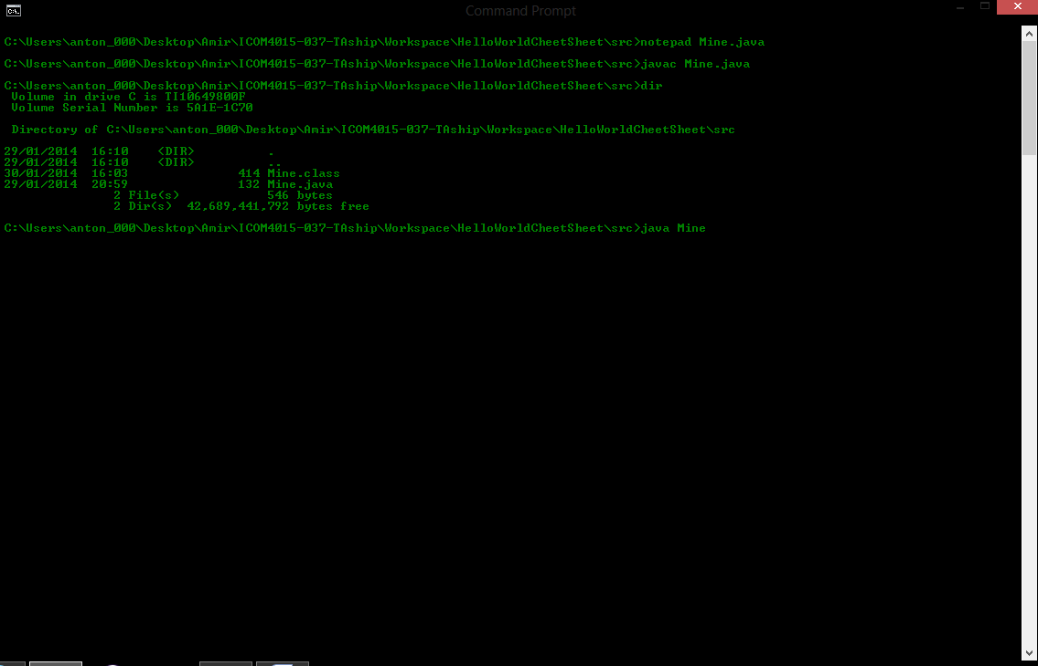

If your curious for what’s inside this .class file Google “javabytecode”.

1. Abracadabra! We have Java !

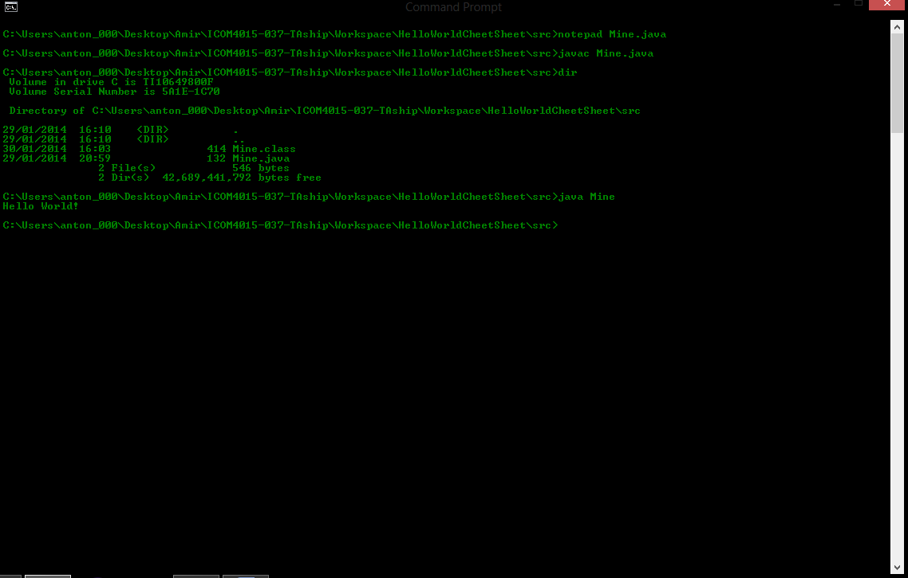

Now go and check out “jdb”(Java Debugger) tool !

### IntelliJ and other paying IDEs



Opinion:

It’s not free I will take a moment to remind you Eclipse is maintained and available at no cost to the developer( you).

### Netbeans and other free IDEs



Opinion:

Not as popular and Eclipse probably has more support.

## In Conclusion

It’s Popular and chances are that they allow you to use in your favourite company. It’s Free!

How to run and compile your code in Eclipse:

Capture7.PNG